WEATHERIZATION ASSISTANCE PROGRAM

MEMO: ALL SUB-GRANTEE 21-06

DATE: February 3, 2021

TO: All Subgrantees and New Service Providers

FROM: Patrick Conway, Weatherization Program Supervisor

CC: Shelly Calvert & Jim Wallace

SUBJECT: SFY 2022 Request for Applications for Service Providers
______________________________________________________________________

This memo is to notify current sub-grantees and other interested parties that the Nevada Housing Division (NHD) has released its annual Request for Application for Service Providers (RFA) for the Weatherization Assistance Program. All agencies interested in participating in this Program must submit a completed application by March 3, 2021 for funding consideration. For details, please review the application packet. (If you need the application packet sent to you, please request it at the email address below.)
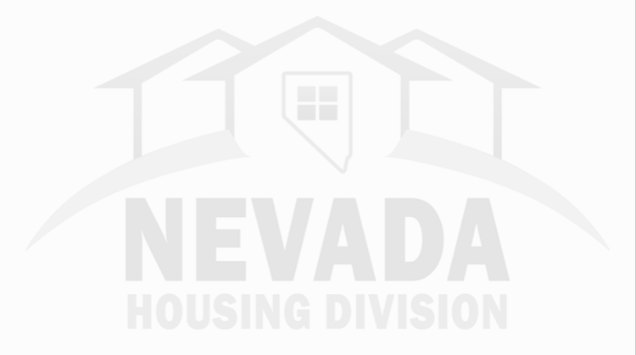
Current Service Providers in good standing and wanting to continue to administer the Weatherization Assistance Program will receive priority for their existing Service Areas.

A copy of a Request for Quotation template and attachments are also included with the application packet. The template may be used to address a Service Providers specific needs for documenting the competitive bid process for the selection of SFY 2022 contractors. If new or additional contractors are being added to the program, or if it has been five years since the Service Provider last sent out a Request of Quotations (RFQ), it is necessary to conduct a new competitive bid process.

Please note there are also the price agreement forms for SFY 2022 (Attachments A & B). Please use these forms both for the RFQ process and the annual contractor cost analysis. Contractor cost information needs to be submitted to NHD no later than 5:00 p.m. on June 1, 2021.

Should you have any questions regarding this matter or need a copy of the complete application packet, please contact NHD staff at patrick.conway@housing.nv.gov or (775) 687-2242.

